Formula Lab

Excel Formulas Guide
Lookup, Logic & Dynamic Arrays
13 functions | 4 sections | worked examples | 1-page revision flowchart

How to use this guide
Start with the flowchart if you are revising in a hurry. Use the section pages when you want the full explanation: what each function does, what its arguments mean, and an example with its result. Every example works on the sample data, so you can type it into Excel and compare.

Section 1  IFERROR and text functions  IFERROR  LEFT  RIGHT  MID | Section 2  Text joins and dynamic arrays  & (ampersand)  SEQUENCE  EDATE | Section 3  LARGE, SMALL, SUMIFS and FILTER  LARGE  SMALL  SUMIFS  FILTER | Section 4  XLOOKUP and INDEX MATCH  XLOOKUP  INDEX + MATCH

One-page revision flowchart
Pick the goal at the top, follow the column, and you land on the formula and its syntax.
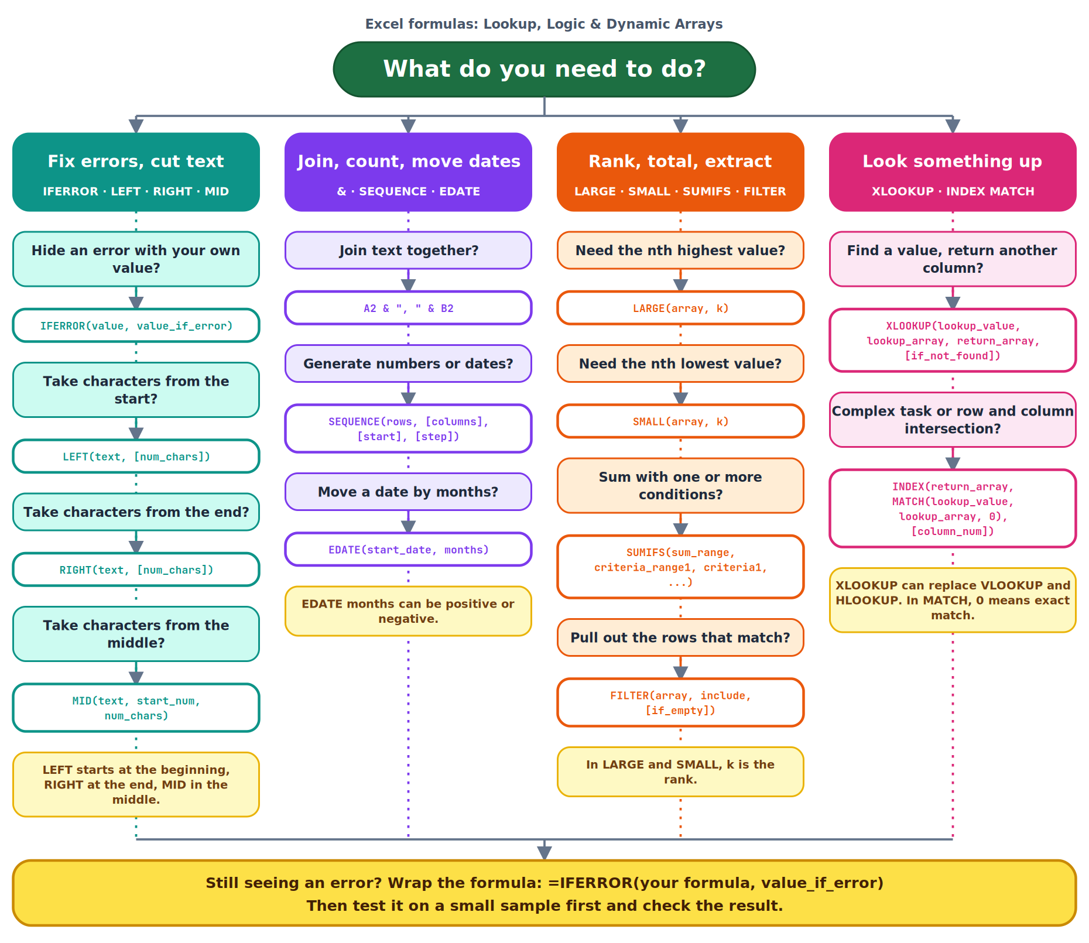

Sample data
Type this into cells A1 to D11 of a blank sheet. Every example in this guide uses it.
Order ID | Channel | Amount | Month
ORD-101 | Amazon Prime | 1200 | 7
ORD-102 | Flipkart | 850 | 3
ORD-103 | Amazon Fresh | 430 | 7
ORD-104 | Myntra | 1500 | 5
ORD-105 | Amazon Prime | 990 | 7
ORD-106 | Flipkart | 2100 | 9
ORD-107 | Myntra | 640 | 3
ORD-108 | Amazon Fresh | 780 | 11
ORD-109 | Flipkart | 1350 | 7
ORD-110 | Amazon Prime | 560 | 5

Quick reference
Function | What it does | Syntax
IFERROR | Show your own value instead of an error | =IFERROR(value, value_if_error)
LEFT | Characters from the start | =LEFT(text, [num_chars])
RIGHT | Characters from the end | =RIGHT(text, [num_chars])
MID | Characters from the middle | =MID(text, start_num, num_chars)
& (ampersand) | Join text together | =A2 & ", " & B2
SEQUENCE | Generate a sequence of numbers or dates | =SEQUENCE(rows, [columns], [start], [step])
EDATE | Move a date by a number of months | =EDATE(start_date, months)
LARGE | The nth highest value | =LARGE(array, k)
SMALL | The nth lowest value | =SMALL(array, k)
SUMIFS | Sum values that meet conditions | =SUMIFS(sum_range, criteria_range1, criteria1, [criteria_range2, criteria2], ...)
FILTER | Extract rows that meet a condition | =FILTER(array, include, [if_empty])
XLOOKUP | Find a value and return its match | =XLOOKUP(lookup_value, lookup_array, return_array, [if_not_found], [match_mode], [search_mode])
INDEX + MATCH | Flexible lookup by position | =INDEX(return_array, MATCH(lookup_value, lookup_array, match_type), [column_num])

Section 1

IFERROR and text functions
Handle errors gracefully and pull pieces out of text.

Remember
- IFERROR(value, value_if_error) shows your own value instead of an error.
- LEFT reads from the start of the text, RIGHT from the end, and MID from the middle.

IFERROR
What it does | Returns your own fallback value instead of an error such as #N/A or #DIV/0!.
Syntax | =IFERROR(value, value_if_error)
Arguments | value The formula or value to check.  value_if_error What to return if the first argument results in an error such as #N/A or #DIV/0!. If there is no error, you get the original result.
Example 1 | =IFERROR(XLOOKUP("ORD-999",A2:A11,C2:C11),"Not found")  Result Not found  ORD-999 does not exist, so the lookup errors and "Not found" is shown instead.
Example 2 | =IFERROR(C2/0,0)  Result 0  Dividing by zero would give #DIV/0!, so 0 is returned.

LEFT
What it does | Extracts characters from the start of the text.
Syntax | =LEFT(text, [num_chars])
Arguments | text The text (or cell) to take characters from.  [num_chars] Optional. How many characters to take from the start of the text.
Example | =LEFT(A2,3)  Result ORD  Takes the first 3 characters of ORD-101.

RIGHT
What it does | Extracts characters from the end of the text.
Syntax | =RIGHT(text, [num_chars])
Arguments | text The text (or cell) to take characters from.  [num_chars] Optional. How many characters to take from the end of the text.
Example | =RIGHT(A2,3)  Result 101  Takes the last 3 characters of ORD-101.

MID
What it does | Extracts a set number of characters from the middle of the text, starting at a position you choose.
Syntax | =MID(text, start_num, num_chars)
Arguments | text The text (or cell) to take characters from.  start_num The position of the first character to take. 1 is the first character.  num_chars How many characters to take, counting from start_num.
Example | =MID(B2,8,5)  Result Prime  Starts at character 8 of "Amazon Prime" and takes 5 characters.

Section 2

Text joins and dynamic arrays
Join text, generate number sequences and move dates by months.

Remember
- Join text with & as in =A2 & "," & B2.
- SEQUENCE(rows, [columns], [start], [step]) generates numbers or dates.
- The months in EDATE can be positive or negative.

& (ampersand)
What it does | Joins pieces of text (and cell values) into one string.
Syntax | =A2 & ", " & B2
Arguments | A2 & "," & B2 Put & between each piece. Literal text such as a comma or a dash goes inside double quotes.
Example | =A2&" - "&B2  Result ORD-101 - Amazon Prime  Combines the order ID, a dash and the channel.

SEQUENCE
What it does | Generates a sequence of numbers or dates.
Syntax | =SEQUENCE(rows, [columns], [start], [step])
Arguments | rows How many rows to generate.  [columns] Optional. How many columns to generate.  [start] Optional. The first number in the sequence.  [step] Optional. The amount added each time.
Example 1 | =SEQUENCE(4,1,10,5)  Result 10 | 15 | 20 | 25  4 rows, 1 column, starting at 10, stepping by 5.
Example 2 | =SEQUENCE(3,2)  Result 1, 2 | 3, 4 | 5, 6  A 3 by 2 grid counting from 1.

EDATE
What it does | Moves a date forward or backward by a number of months. Use a negative number to go back.
Syntax | =EDATE(start_date, months)
Arguments | start_date The date to start from.  months How many months to move. A positive number goes forward and a negative number goes back.
Example 1 | =EDATE("2026-01-31",1)  Result 2026-02-28  One month after 31 Jan lands on the last day of February.
Example 2 | =EDATE("2026-03-15",-2)  Result 2026-01-15  A negative value moves two months earlier.

Section 3

LARGE, SMALL, SUMIFS and FILTER
Rank values, add up by condition and pull out matching rows.

Remember
- In LARGE and SMALL, k is the rank you want.
- SUMIFS takes a sum range plus one or more criteria pairs, and text criteria can use wildcards like "Amazon*".
- FILTER results fill into the adjacent cells.

LARGE
What it does | Returns the nth highest value in a range. k is the rank.
Syntax | =LARGE(array, k)
Arguments | array The data range to look in.  k The rank you want. 1 is the highest value, 2 the second highest, and so on.
Example | =LARGE(C2:C11,2)  Result 1500  The 2nd highest amount.

SMALL
What it does | Returns the nth lowest value in a range. k is the rank.
Syntax | =SMALL(array, k)
Arguments | array The data range to look in.  k The rank you want. 1 is the lowest value, 2 the second lowest, and so on.
Example | =SMALL(C2:C11,1)  Result 430  The lowest amount.

SUMIFS
What it does | Adds up values that meet one or more conditions. Wildcards such as * work in text criteria.
Syntax | =SUMIFS(sum_range, criteria_range1, criteria1, [criteria_range2, criteria2], ...)
Arguments | sum_range The cells to add up.  criteria_range1 The range to test with the first condition.  criteria1 The first condition, such as 7 or "Amazon*".  [criteria_range2, criteria2] Optional. More range and condition pairs. Every condition must be met for a row to be added.
Example 1 | =SUMIFS(C2:C11,D2:D11,7)  Result 3970  Total amount for month 7.
Example 2 | =SUMIFS(C2:C11,B2:B11,"Amazon*")  Result 3960  Total for every channel that starts with Amazon.

FILTER
What it does | Extracts the rows that meet a condition. The results spill into the adjacent cells.
Syntax | =FILTER(array, include, [if_empty])
Arguments | array The data to return rows from.  include A test that gives TRUE or FALSE for each row, such as D2:D11=7.  [if_empty] Optional. What to show when no rows match.
Example 1 | =FILTER(A2:C11,D2:D11=7)  Result ORD-101, Amazon Prime, 1200 | ORD-103, Amazon Fresh, 430 | ORD-105, Amazon Prime, 990 | ORD-109, Flipkart, 1350  All orders placed in month 7.
Example 2 | =FILTER(A2:C11,C2:C11>5000,"None")  Result None  No amount is above 5000, so the if_empty text is returned.

Section 4

XLOOKUP and INDEX MATCH
Find a value in one column and return the matching value from another.

Remember
- XLOOKUP can replace VLOOKUP and HLOOKUP.
- INDEX MATCH is the flexible choice for complex tasks and for finding data at the intersection of a row and a column.
- In MATCH, match_type 0 finds an exact match.

XLOOKUP
What it does | A modern lookup that can replace VLOOKUP and HLOOKUP. It finds a value in one column and returns the matching value from another.
Syntax | =XLOOKUP(lookup_value, lookup_array, return_array, [if_not_found], [match_mode], [search_mode])
Arguments | lookup_value The value to find.  lookup_array The range to search in.  return_array The range to return the matching value from.  [if_not_found] Optional. What to show instead of #N/A when nothing matches.  [match_mode] Optional. How matches are made. The default is an exact match.  [search_mode] Optional. The search direction. The default searches from first to last.
Example | =XLOOKUP("ORD-106",A2:A11,C2:C11,"Not found")  Result 2100  Finds ORD-106 and returns its amount. The 4th argument is shown if nothing matches.

INDEX + MATCH
What it does | MATCH finds the position of a value (match_type 0 means exact match) and INDEX returns the item at that position. Together they are very flexible, especially for the intersection of a row and a column.
Syntax | =INDEX(return_array, MATCH(lookup_value, lookup_array, match_type), [column_num])
Arguments | MATCH(lookup_value, lookup_array, match_type) Finds the position of the value in the range. A match_type of 0 finds an exact match.  INDEX(return_array, position, [column_num]) Returns the item at that position. Add column_num when the range has more than one column.
Example 1 | =INDEX(C2:C11,MATCH("ORD-106",A2:A11,0))  Result 2100  MATCH returns position 6 and INDEX returns the 6th amount.
Example 2 | =INDEX(A2:D11,MATCH("ORD-106",A2:A11,0),2)  Result Flipkart  Uses the optional column number to return the 2nd column (Channel) of that row.

